Sleep Patterns of Students in Undergrad

Jasmine Roberts

CTEC 128-102-Fall2024

Bowie State University

Marcella Wilson

December 3, 2024

**Sleep Patterns of Students in Undergrad 3**

Research Questions 3

**Considering Data 4**

Dataset Link: Student Sleep Patterns 4

Dataset Code: Dataset Cleanup Code (This code was used for dataset clean up for missing values inside of the sheet.) 4

**Central Tendencies 5**

**Measures 6**

**Visualizations 6**

**Specific Tasks 6**

**Summary Findings 7**

Question 1 7

Were you able to answer your statistical questions? 7

Question 2 7

What conclusions could be drawn from your exploration and analysis of the data? 7

Question 3 8

Why are your findings important? How can they be used? 8

**Screenshots of Charts 9**

Caffeine Intake vs. Sleep Quality 9

Age vs. Screen Time 10

University Year Count 10

Sleep Duration (Average) vs. Age 11

12hr vs. 24hr 12

# Sleep Patterns of Students in Undergrad

This project is based on analyzing how much sleep students get in undergrad whether they have insomnia or if they are getting the recommended amount of sleep each night. There will be a comparison of each statistic under each column and analyzing which student (s) got the most sleep, and which student (s) didn’t. There will be an analysis using Google Sheets with the use of Pivot charts, and the basic uses of mean, median mode and range. Along with the datasheet there is a Python code that pulls the “Student Sleep Patterns” data from wherever the .csv file is saved on your PC, and it reads the information and generates a graphical analysis of the sleep patterns. This is a way of analyzing the data automatically for errors that we wouldn’t be able to see with a naked eye. The datasets include the information below of a total of 501 undergrad students at a university. This will point out any correlation of the students' patterns that we may come across during the duration of the project. There are a total of 501 students.

## *Research Questions*

1. Which age group developed insomnia the most?
2. Which age group received the recommended amount of sleep?
3. What is the total sleep duration of each student?

***The columns of the dataset includes:***

* + Age
  + Gender
  + Year
  + Sleep Duration
  + Study Hours
  + Screen Time on your phone
  + Caffeine Intake
  + Physical Activity
  + Sleep Quality ( How good is the sleep)
  + Weekday Sleep Start ( What time did you fall asleep)
  + Weekday Sleep End ( What time did you wake up)
  + Weekend Sleep Start ( What time did you fall asleep)
  + Weekend End (What time did you fall asleep)
  + Student ID
  + Caffeine intake ( caffeine partakes in the effect of insomnia, if you drink caffeine to close to bedtime)

# Considering Data

Google Sheets will be used as a spreadsheet to visualize and store the student sleep pattern data [Kaggle.com](http://kaggle.com), will be the dataset website that the data is going to be gathered from. Kaggle.com is a data science and machine learning platform, you can access free dataset, and coding resources.

## *Dataset on Google Sheets:* [*Student Sleep Patterns*](https://docs.google.com/spreadsheets/d/1MfLcyS8LzeFriSbF1v7ZEiFyl3j84dLPsaUptima9tg/edit?usp=sharing)

## *Dataset Link:* [Student Sleep Patterns](https://www.kaggle.com/datasets/arsalanjamal002/student-sleep-patterns?resource=download)

## *Dataset Code:* [Dataset Cleanup Code](https://www.kaggle.com/code/vishalrofficial/sleep-patterns-analysis-in-students) (This code was used for dataset clean up for missing values inside of the sheet.)

This data can be reliable because it is gathered from a well known data science and machine learning website. Also, a code was provided to make sure there isn't any missing value inside of the data. This will point out any correlation of any of the student(s) patterns in each column.

In order to answer the previously stated research questions

The following columns are needed for “ Student Sleep Pattern” dataset statistics:

* Age
* University Year
* Sleep Duration
* Caffeine Intake
* Screen Time
* Weekday Sleep End
* Weekend Sleep Start
* Weekend Sleep End
* Study Hours
* Physical Activity

The following columns that won't be needed for “ Student Sleep Pattern” dataset statistics (for privacy reasons):

* Student ID
* Gender

The calculations that would be put in place for the dataset would be the mean/average, median mode and range. Each column can be averaged out; it just depends on which columns I would want to compare. The charts that I will create are comparing two or more columns of their sums. For example if I want to compare Age to Sleep Hours, and see if the sleep duration depends on a specific age group.

# Central Tendencies

The central Tendencies that will be used are:

* Mean: the average of all of the subject columns or one by one to reveal the total
* Median: the middle number of the sleep pattern data set, or two by two columns
* Mode: the number(s) the appears the most often in the dataset
* Range: the difference between the high and low values in the dataset
* Sum: adding values

# Measures

One measure can be the range of the columns and to see how many students are getting the same amount of sleep duration. This will symbolize the sleep duration of every student, and you will be able to pick out similarities and differences.

# Visualizations

The visualizations that will be useful for the data is:

* Pivot Tables
* Histograms
* Column Charts
* Bar Charts
* Line Charts
* Pie Charts

# Specific Tasks

Tasks to be completed to answer the previously stated research questions:

* Analyzing the data to see similarities
* Analyzing the data to see differences
* Analyzing if there's any correlations with the sleep patterns among age
* Analyzing if there's any correlations with the sleep patterns among caffeine intake
* Configure the total number of sleep duration for each student

# Summary Findings

## Question 1

### Were you able to answer your statistical questions?

* Which age group developed insomnia the most?
* Which age group received the recommended amount of sleep?
* What is the total sleep duration of each student?

Yes, I was able to answer my questions because they weren't really complex to a point where I had to do many calculations. The Column, Bar, Line and Pie Charts were very helpful with my calculations.

The minimal calculations that were included were mean, average, mode, range and sum inside of the charts I created to answer all three of my questions.

## Question 2

### What conclusions could be drawn from your exploration and analysis of the data?

Most of the University students are Juniors, which is their third year. Junior year is usually the year when reality starts to set in, and stress becomes more of a problem that can cause the lack of rest and more intake of caffeine. Secondly, the more caffeine students ingested the worse their sleep quality was. According to the ”Caffeine Intake vs. Sleep Quality” bar chart a student rated their sleep quality a 2 out of 10, and their caffeine intake was 4 out of 10. The higher the caffeine intake, your sleep quality won't be as good as someone who had less caffeine. Thirdly, age plays a big part of the dataset, mostly in the “Screentime” column. The average of the Screen Time is 188.3, that number is the total hours of screen time for the 501 students. According to the “Screen Time vs. Age” chart, 18 and 21 year olds have the most screen time. The oldest student in the dataset is 25 years old. Ages 19, 20, 22, 23, 24, 25 have the least screen time according to the chart. According to the “Sleep Duration vs. Age” column chart, I averaged out the Sleep Duration to see the average of the sleep duration hours for each student, then I counted the students age’s and combined their ages into their sleep duration. Evidently, on the average 24 year olds have gotten the most amount of sleep. 18, 19, 20 , 21, 22, 23, and 25 year olds have the most insomnia.

Lastly, is the comparison of each student's time they went to sleep and their awake time on the weekday and the weekends. Usually students go to sleep later when they know they dont have school the next day, which is usually on the weekend. Most students stayed up later than they would on a weekday. According to the 12hr vs. 24hr datasheet I have 4 charts displayed, the times are in military time. Now, for each chart I have the “Sleep Start Times”on the x-axis, and a count of how many students fell asleep around those times on the y-axis. This setup was used for all charts on that datasheet page ( Sleep Start Time During The Weekday/Weekend, Sleep End Time During The Weekday/Weekend). On average, the majority of the students went to sleep around 1-2am during the weekdays, and they went to sleep around 5am on the weekend. Although, they woke up around 10am during the weekdays, and woke up around 4pm during the weekdays.

## Question 3

### Why are your findings important? How can they be used?

My findings are important because it is based on real life, and what college students go through in undergrad as far as their sleep health. This project was more in-depth of how much a student can lack sleep based on various activities such as physical activity or screen time. My findings can be used as a case study, or another statistics project with a different or similar goal as mine.

# Screenshots of Charts

# Caffeine Intake vs. Sleep Quality

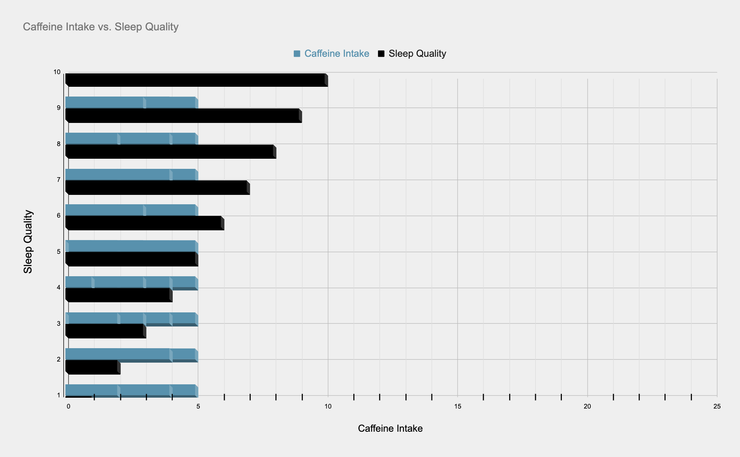

## Age vs. Screentime

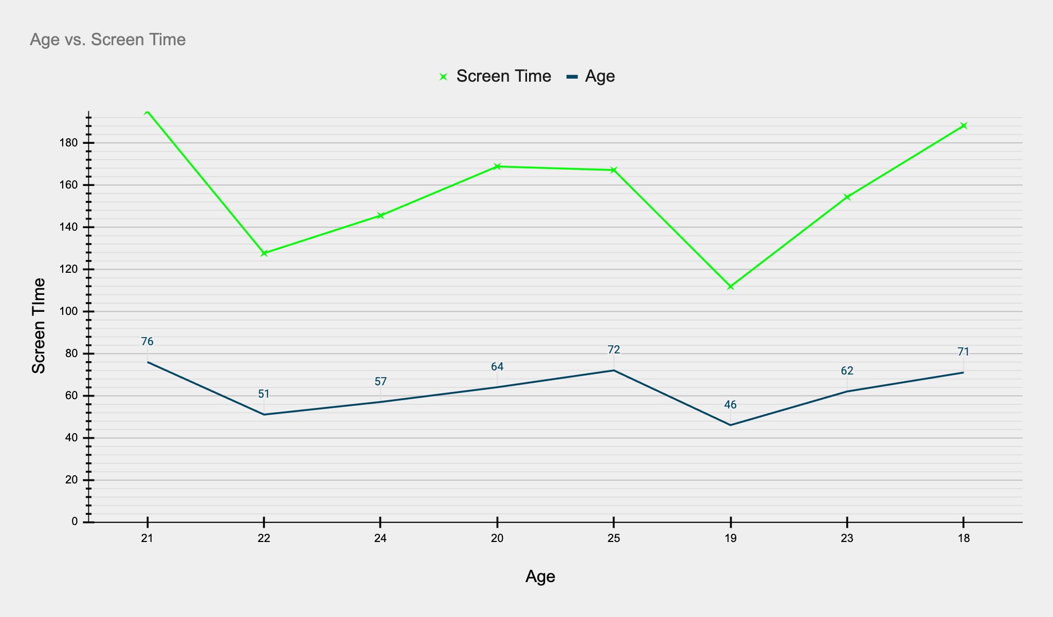

## University Year Count

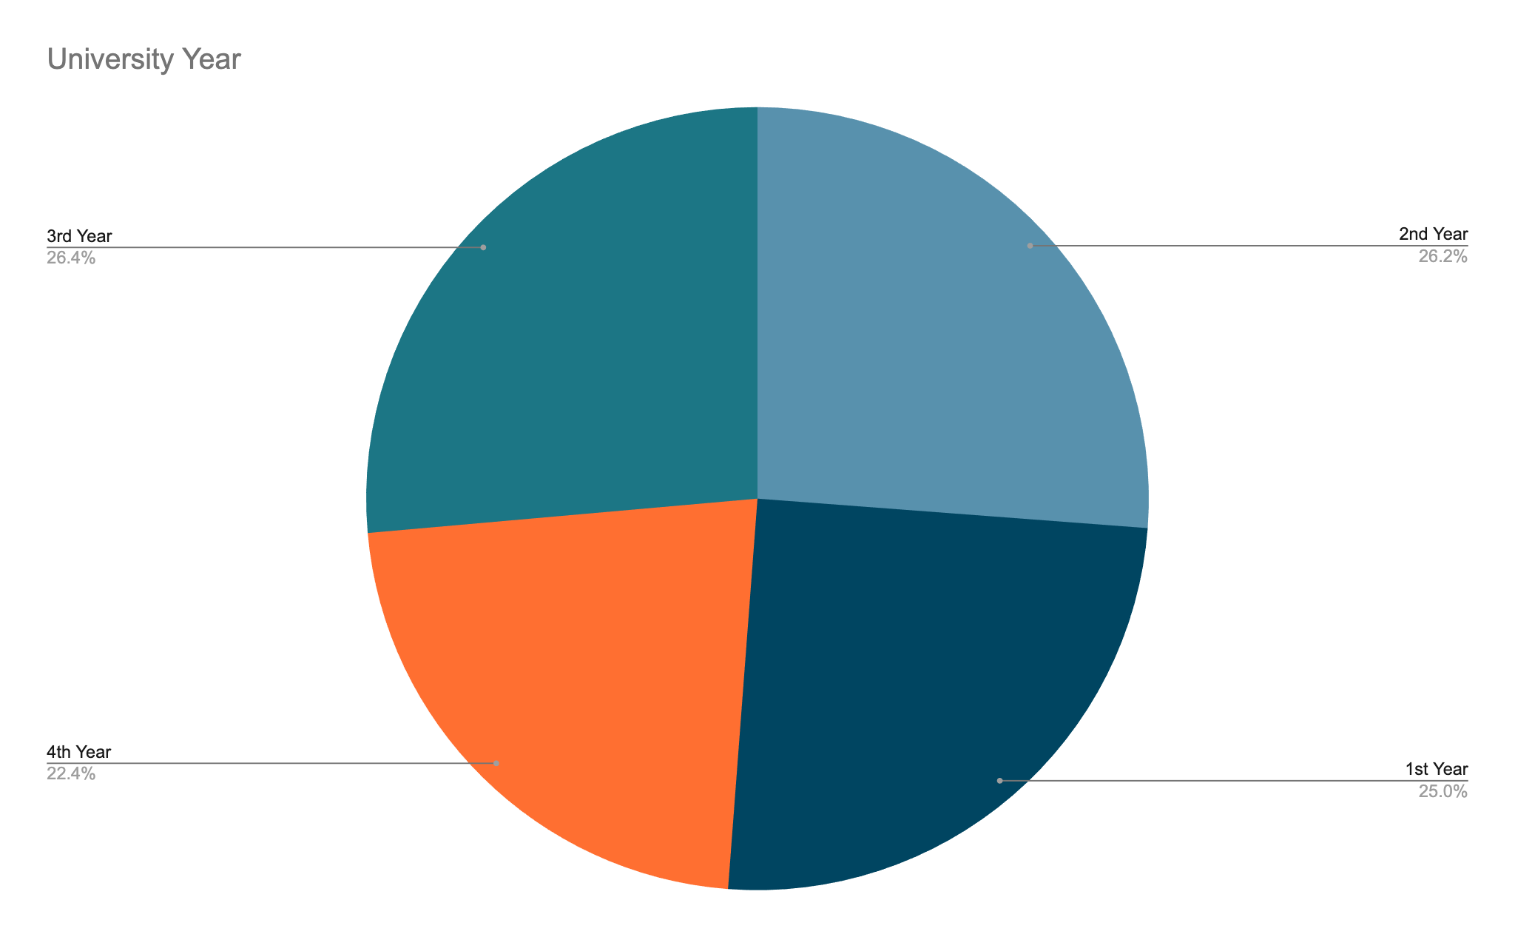

## 

## Sleep Duration (Average) vs. Age

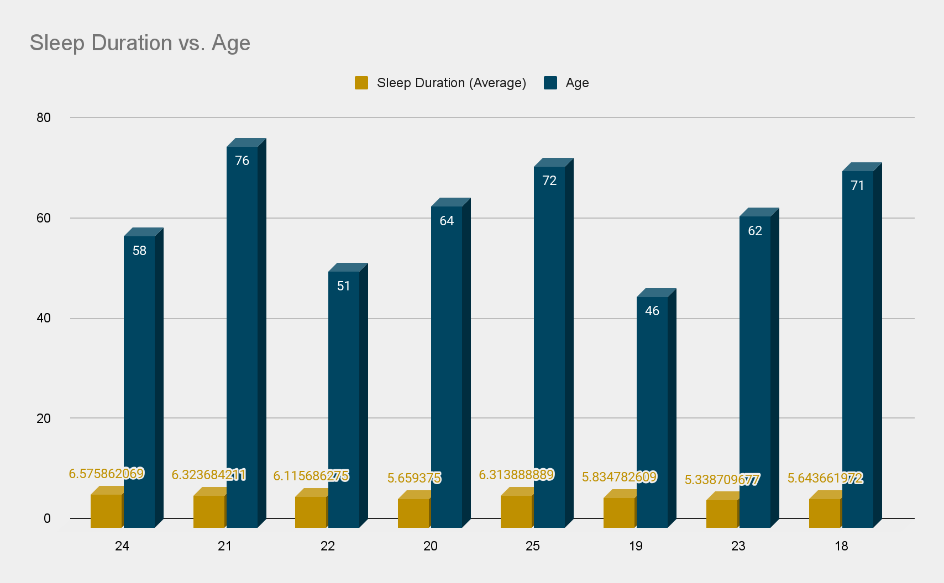

## 12hr vs. 24hr

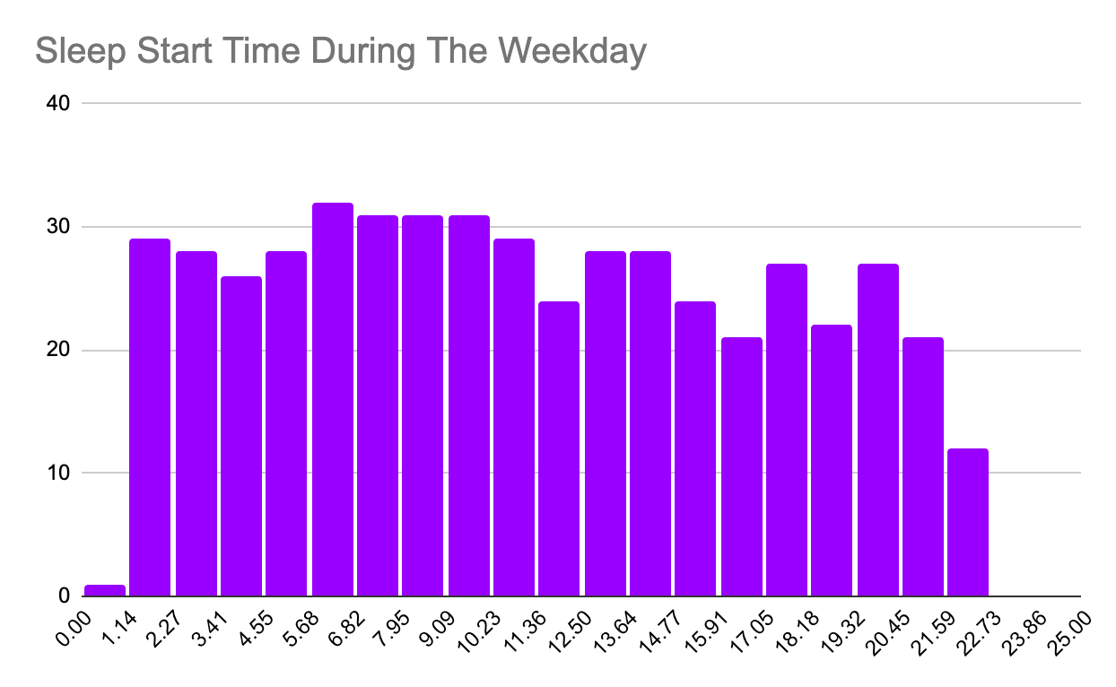

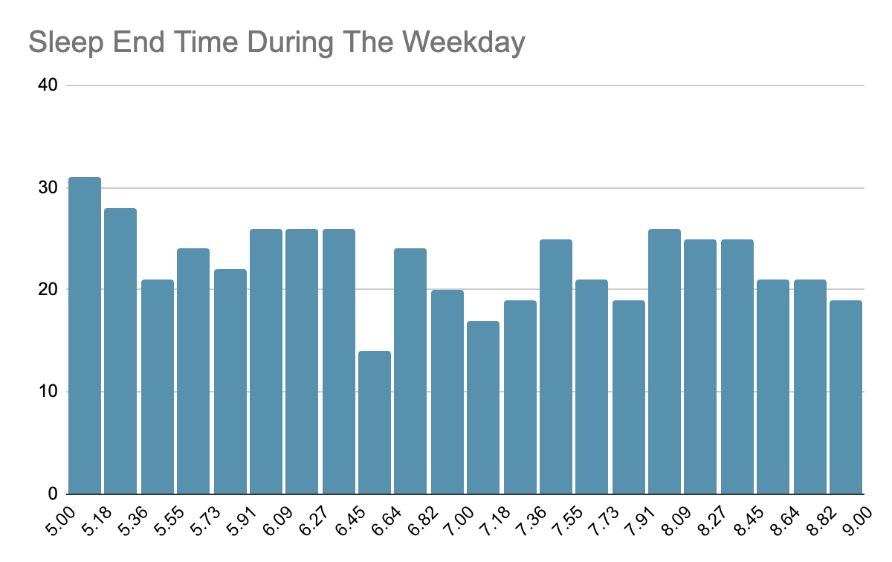

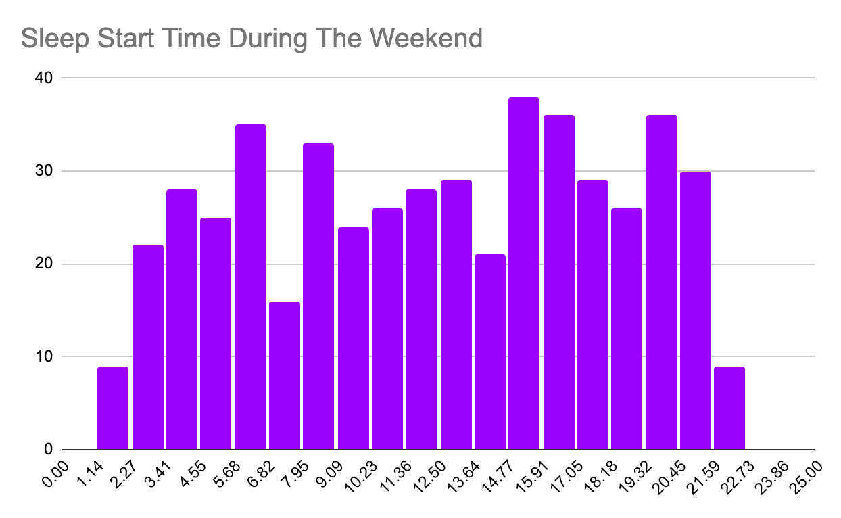

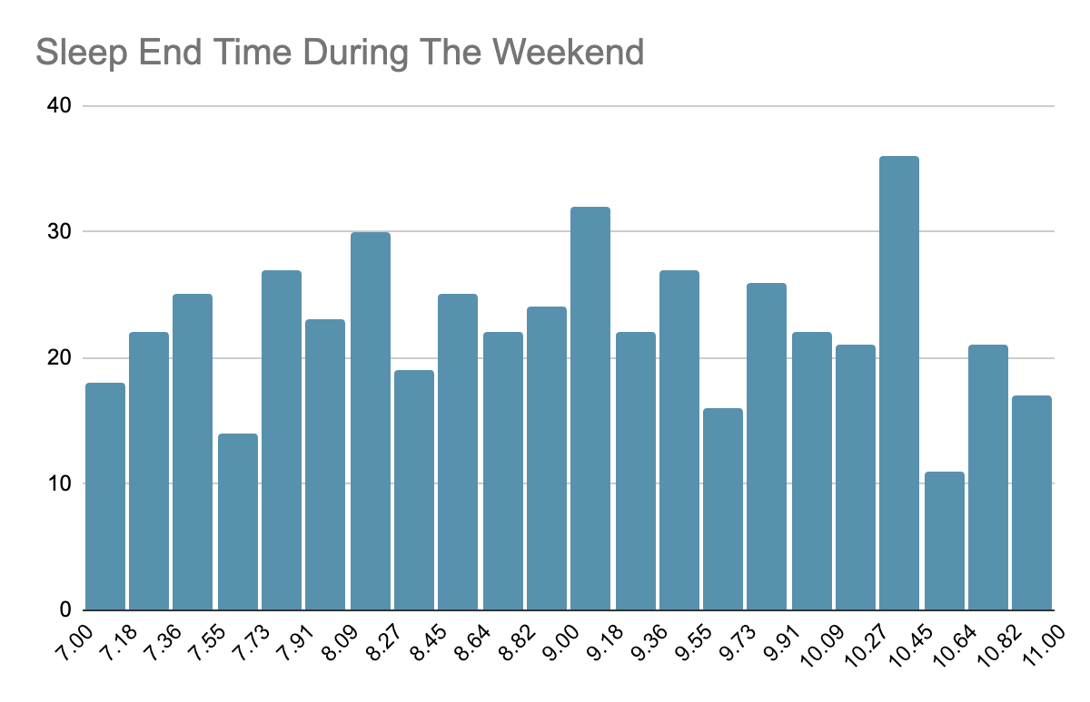

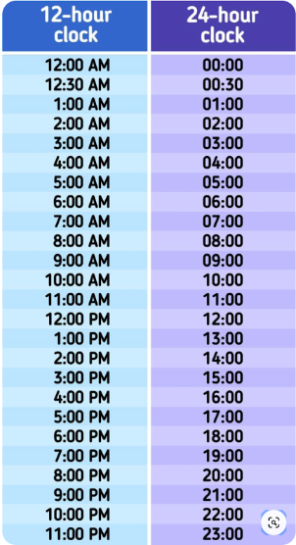

**References**

Jamal, A. (n.d.). *Student Sleep Patterns*. Kaggle. Retrieved December 2, 2024, from https://www.kaggle.com/datasets/arsalanjamal002/student-sleep-patterns/data